AISWCD Board, District Board members and District staff:

On September 6th, the AISWCD Executive Committee met by conference call. The agenda, minutes, and background materials attached. We discussed a wide range of very important topics so I wanted to provide bullet points and notes, from my perspective, of the meeting’s highlights.

-Additional funding for Districts: OUR MOST PRESSING ISSUE is funding. We are all busy this time of year, but our window of opportunity to address the Districts’ critical funding needs is now and we need your help. During our meeting Mike Hoffman discussed strategy, timing, and how to approach Legislators to get more money from the budget released to Districts. Mike feels our best chance for success is to have a specific outline of how additional money will be spent and how it will benefit each Legislator’s District. He would like to approach Legislators soon – by early October.
Building this “Funding Plan” is where we need District help! I know I have been unclear on District Plans. What we truly need from you are plans for District Projects that address specific resource concerns in your area. If as many districts as possible will submit District Project details, the AISWCD team can compile this data from across the state and come up with a comprehensive “Funding Plan”. We will then take this “Funding Plan” and petition Legislators, show them the impact SWCDs can have to their constituents and communities, and request they support releasing additional and critical funds to SWCDs.
We need as many strong District Project proposals as possible SOON! Please send by September 29th your District’s proposed projects using the Project Template we will be sending you later this week.
I well know that harvest is upon us and time is very short. Unfortunately, this is also the time of year Legislators discuss State’s budget issues. We anticipate that SWCDs will receive $5 million as they did last year but there is an additional $8.5 million in the State budget for SWCDs that has not been released. By having a “Funding Plan” that represents all SWCDs across the State, we will have a powerful message to carry to our Legislators on how we will spend the additional funds while addressing our mission of “Clean Water and Healthy Soils”. While this is not a requirement, having as many quality project proposals as possible by September 29th will help with our legislative efforts. In this tight budget situation, I certainly can’t guarantee that we will get more money. But, I am sure of what we will get if we don’t try!

Page 1
We plan to have the Project Proposal Template you can use you can use to submit your District Project description to you later this week. Please submit 1, 2, or multiple Projects. Your IDOA Rep where and when possible is willing to help to develop project proposals as are our partner groups. I am always available to help answer questions. What we are looking for is: 1) What is the District’s resource concern? 2) What does the District propose to do to address the resource concern? 3) How will you measure success? 4) What resources will you need to do this project? The Project Proposal Template will help you present this information clearly. Innovative projects and measurement strategies are encouraged!

-Steve Chard, by agreeing to join our Executive Board as ex officio, brings a welcome avenue of valuable input, along with enhanced communication and information sharing. Steve reported that Grant Agreements are due by Sept. 15.
-NRCS Contribution Agreement: Sheryl reported more delays due to the NRCS National Grants & Agreements Team backlog. New timeframe is between October-December (more info in the minutes).

-Strategic Plan Implementation: Becky presented the Draft Implementation Plan. We need input from everyone to prioritize the Recommendations (page 2 of Plan). What should we address first? Task groups reported on progress being made on the 3 key resolutions passed at Summer Conference: 1) employee training, 2) director training, and 3) upgrading the foundation.

-Kelly’s Departure: We are sad to be losing a very valuable member of our team, but wish Kelly all the best in her new job. You will be missed! Sheryl has agreed to act as interim Director while we seek a new candidate for this important position. Please feel free to widely post the attached Job Announcement.

-New Financial Manager: Alan Howard was hired in August. He is already shaping up the AISWCD books and has become a welcomed addition to our management team.

-Summer conference 2018: Bids are in and we have decided to accept an attractive bid that will move our Summer Conference 2018 to the Wyndham Hotel in downtown Springfield.

Sincerely,
Steve Stierwalt, AISWCD President
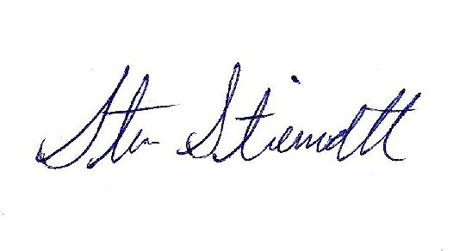 Page 2

